# **Image Streamer Artifact Bundle of RHEL 7.2**

The Image Streamer Artifact Bundle of RHEL 7.2 includes artifact which is helpful to personalize the RHEL 7.2 OS.

### Artifact Bundle: HPE-RHEL-7.2-artifacts-12-20-2016

### 

This artifact personalizes the RHEL 7.2 OS based on user input. It contains 2 build plan and 9 plan scripts.

## **Prerequisite:**

### Filesystem:

The filesystem of RHEL 7.2 image should be xfs or ext4.

We assume that root partition (/) is mounted on /dev/sda3 or /dev/rhel/root . If the root partition is not on the mentioned device the user has to edit RHEL-7.2-mount-and-validate plan script.

### LogicalVolumeMangement (LVM):

User has to add a local drive for LVM type partitioning, while creating the server profile user should edit “Integrated storage controller mode” option of local storage to add a local drive for the server. There will be only two partitions done.

### NIC Teaming:

For NIC teaming the user should add two network connection with same VLAN ID for teaming in the add network section of server profile. And while selecting the Team0NIC1 and Team0NIC2 the network should be of same VLAN ID.

### Adding Multiple NIC’s:

While selecting the MgmtNIC1, MgmtNIC2, MgmtNIC3 and MgmtNIC4 the user should select a different network. User should not use the same network for selecting the MgmtNIC’s.

### Adding the user:

The user can add one or more users. User can add more users either with comma separated or semicolon separated or space separated and the password will be same for all the user. User can change password on their first login.

## **Build Plans**

### Build Plan: RHEL-7.2-personalize-and-configure-NICs-reg-rhel-LVM-BP

Build Plan personalizes the RHEL 7.2 server by creating a new users, applying multiple nic configuration, allowing the network to access from outside world, updating the hostname, creating partition on the disk, registering the RHEL 7.2 with the bootstrap link, enabling SELINUX service, server hardening and changing the root password as per user parameters.

|  |  |
| --- | --- |
| **Steps: Plan Script Names** | **Attributes** |
| RHEL-7.2-mount-and-validate |  |
| RHEL-7.2-configure-multiple-NICs | MgmtNIC1(NIC)  MgmtNIC2(NIC)  MgmtNIC3(NIC)  MgmtNIC4(NIC)  TotalMgmtNICs(Option) |
| RHEL-7.2-configure-hostname | DomainName(FQDN) |
| RHEL-7.2-configure-users | NewRootPassword(Password)  NewUserName(String)  NewUserPassword(Password) |
| RHEL-7.2-configure-partition-using-LVM | DiskName(String)  FirstPartitionSize(Number)  LogicalVolumeGroupName(String)  LogicalVolumeName(String)  LogicalVolumeSize(Number)  SecondPartitionSize(Number) |
| RHEL-7.2-manage-services | SSH(Option) |
| RHEL-7.2-register-rhel | BootstrapLink(String)  UpdateYum(Option) |
| RHEL-7.2-unmount |  |
|  | |

### Build Plan:  RHEL-7.2-personalize-and-NIC-teamings-reg-rhel-LVM-BP

 Build Plan personalizes the RHEL 7.2 server by creating a new users, creating multiple nic teaming, allowing the network to access from outside world, updating the hostname, creating partition on the disk, registering the RHEL 7.2 with the bootstrap link, enabling SELINUX service, server hardening and changing the root password as per user parameters.

|  |  |
| --- | --- |
| **Steps: Plan Script Names** | **Attributes** |
| RHEL-7.2-mount-and-validate |  |
| RHEL-7.2-configure-multiple-NIC-teaming | FirstNicTeamName(String)  SecondNicTeamName(String)  Team0NIC1(NIC)  Team0NIC2(NIC)  Team1NIC1(NIC)  Team1NIC2(NIC)  TotalNicTeamings(Option) |
| RHEL-7.2-configure-hostname | DomainName(FQDN) |
| RHEL-7.2-configure-users | NewRootPassword(Password)  NewUserName(String)  NewUserPassword(Password) |
| RHEL-7.2-configure-partition-using-LVM | DiskName(String)  FirstPartitionSize(Number)  LogicalVolumeGroupName(String)  LogicalVolumeName(String)  LogicalVolumeSize(Number)  SecondPartitionSize(Number) |
| RHEL-7.2-manage-services | SSH(Option) |
| RHEL-7.2-register-rhel | BootstrapLink(String)  UpdateYum(Option) |
| RHEL-7.2-unmount |  |

## **Plan Scripts**

### Plan Script: RHEL-7.2-mount-and-validate

This plan script lists all mount partitions and mounts the root partition of the image.

After the mount script validates golden image to check whether it is appropriate image to use. And verifies whether the image was captured by the Image Streamer or not.

### Plan Script: RHEL-7.2-configure-multiple-NICs

This script gives the user an option of configuring four NICs and user as to select the total number of NICs to configure as DHCP or Static as per their requirement. User has to add public network while creating server profile.

Attributes:

MgmtNIC1 (NIC)

This attribute is of type NIC which has four sub attribute i.e. MgmtNIC1.dhcp, MgmtNIC1.gateway, MgmtNIC1.ipaddress, and MgmtNIC1.mac where all this attribute used to edit the network file of 1st NIC in RHEL 7.2.

MgmtNIC2 (NIC)

This attribute is of type NIC which has four sub attribute i.e. MgmtNIC2.dhcp, MgmtNIC2.gateway, MgmtNIC2.ipaddress, and MgmtNIC2.mac where all this attribute used to edit the network file of 2nd NIC in RHEL 7.2.

MgmtNIC3 (NIC)

This attribute is of type NIC which has four sub attribute i.e. MgmtNIC3.dhcp, MgmtNIC3.gateway, MgmtNIC3.ipaddress, and MgmtNIC3.mac where all this attribute used to edit the network file of 3rd NIC in RHEL 7.2.

MgmtNIC4 (NIC)

This attribute is of type NIC which has four sub attribute i.e. MgmtNIC4.dhcp, MgmtNIC4.gateway, MgmtNIC4.ipaddress, and MgmtNIC4.mac where all this attribute used to edit the network file of 4th NIC in RHEL 7.2.

TotalMgmtNICs (Option)

This attribute is of type option where user as to select to configure the number of NICs to the server.

### Plan Script: RHEL-7.2-configure-multiple-NIC-teaming

This script gives the user an option of configure two NIC teaming and user as to select the total number of NICs for teaming as DHCP or Static as per their requirement. User has to add public network while creating server profile and can also specify the name for teaming the NICs.

Attributes:

FirstNicTeamName (String)

User can specify the name for first NIC teaming.

SecondNicTeamName (String)

It is of type string and can specify the name for second NIC teaming.

Team0NIC1 (NIC)

This attribute is of type NIC which has three sub attribute i.e. Team0NIC1.gateway, Team0NIC1.ipaddress and Team0NIC1.mac where all this attribute used for network teaming Team0NIC1 and Team0NIC2 as static or dhcp.

Team0NIC2 (NIC)

This attribute is of type NIC which has three sub attribute i.e. Team0NIC2.gateway, Team0NIC2.ipaddress and Team0NIC2.mac where all this attribute used for network teaming Team0NIC1 and Team0NIC2 as static or dhcp.

Team1NIC1

This attribute is of type NIC which has three sub attribute i.e. Team1NIC3.gateway, Team1NIC3.ipaddress and Team1NIC3.mac where all this attribute used for network teaming Team1NIC1 and Team1NIC2 as static or dhcp.

Team1NIC2

This attribute is of type NIC which has three sub attribute i.e. Team1NIC3.gateway, Team1NIC3.ipaddress and Team1NIC3.mac where all this attribute used for network teaming Team1NIC1 and Team1NIC2 as static or dhcp.

TotalNicTeamings (Option)

Gives option to select either one or two NIC teaming for the server.

#### Sample test screenshot

(Note: The screenshot has been captured through SSH console)

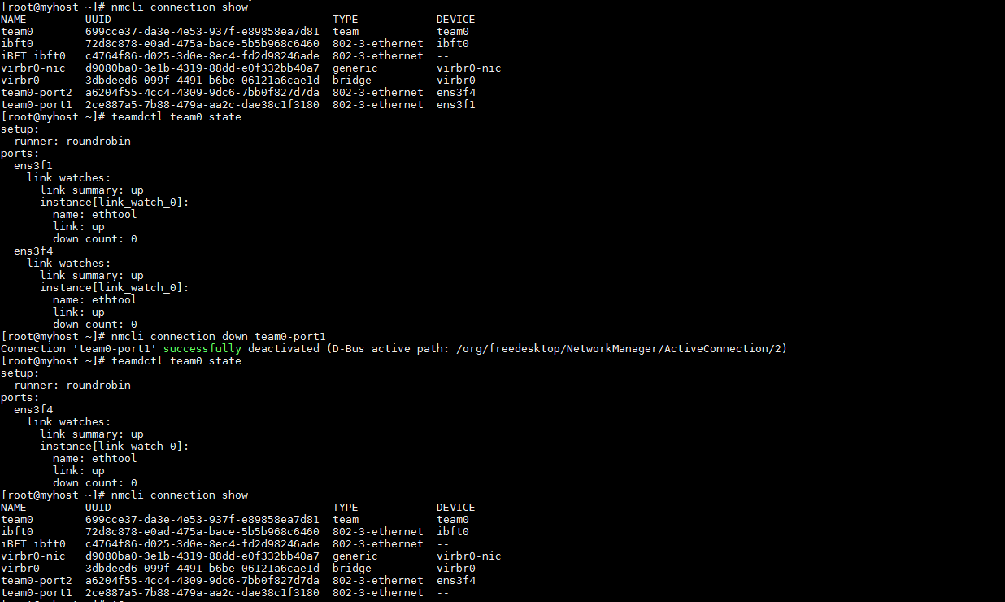

### Plan Script: RHEL-7.2-configure-hostname

This scripts assigns the hostname given by user, adds the alias in /etc/hosts file with respective to the interface name present in the /tmp/interface name file and also delete the default gateway so that the network can be accessible from the outside world.

The hostname assignment is done in Image Streamer only, but updating /etc/hosts should be done when the host is up. So the script for updating hosts is added in rc.local file which is present in /etc/rc.d folder. And this script has to be added next either to the plan script RHEL-7.2-configure-multiple-NIC-teaming or RHEL-7.2-configure-multiple-NICs.

Attributes:

DomainName (FQDN)

This attribute is of type FQDN the user must specify the full domain name to which the network should belong.

### Plan Script: RHEL-7.2-configure-users

Changes the root password and adds new users with data given by the user while creating the server profile. This scripts are executed in the rc.local file to do the operations. Script takes new root password and new user details as parameters.

Attributes:

NewRootPassword (Password)

Attribute is used to change the root password of the server based on user input.

NewUserName (String)

String used to create a new users to the server. And multiple user name can also give by either comma separated or semicolon separated.

NewUserPassword (Password)

This attribute is of type Password and used to set for the newly created user. Same password is assigned to the multiple users given by the users.

### Plan Script: RHEL-7.2-configure-partition-using-LVM

Script partitions the newly added disk (example /dev/sda) into to two partitions (example /dev/sda1 /dev/sda2) of given size. Creates a logical volume group and logical volume and create ext4 file system and mounts the given directory to the new logical volume and adds the entry to /etc/fstab. User have to add local disk while creating server profile.

Attributes:

DiskName (String)

It is a string which takes the name of the disk to partition.

FirstPartitionSize (Number)

This attribute take the size of the first partition to be in GiB. This is a special attribute which is recognized by the Image Streamer.

LogicalVolumeGroupName (String)

This attribute is of type string it takes the name of logical volume group to create in the disk.

LogicalVolumeName (String)

The new logical volume to be create in the disk. It is of the type string.

LogicalVolumeSize (Number)

Size of the logical volume to be create will be in GiB unit.

SecondPartitionSize (Number)

This attribute take the size of the second partition to be in GiB. This is a special attribute which is recognized by the Image Streamer.

#### Sample test screenshot:

(Note: The screenshot has been captured through SSH console)

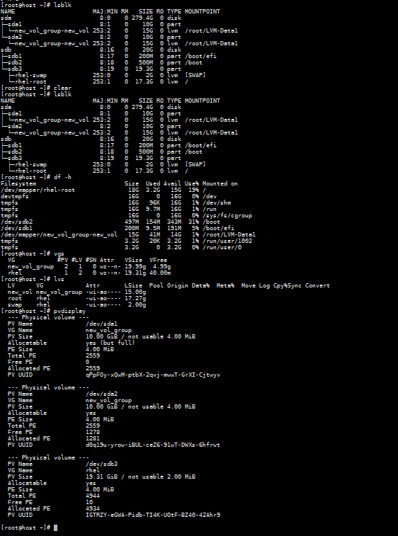

### Plan Script: RHEL-7.2-manage-services

This script enable the SELINUX service which supports access control security policies and also does the server hardening like enabling the SSH service and disabling the firewall service so, that the network can be access through the external network. It also gives option to user either to enable or disable the SSH.

Attributes:

SSH (Option)

This attribute is an option either to enable or disable the SSH service of the server.

### Plan Script: RHEL-7.2-register-rhel

Register the RHEL 7.2 yum repository with the bootstrap link specified by the user and it also gives an option to user either to update the yum repo or not.

Attributes:

BootstrapLink (String)

User as to specify the bootstrap link to which the RHEL 7.2 yum repo has to register.

UpdateYum (Option)

This attribute is an option to the user either to update the yum repo or not.

### Plan Script: RHEL-7.2-unmount

Script sets up rc.local file and removes the temporary directory created during mount.

Unmounts the root partition.

## **Procedure for creating a Linux Golden Image**

The Process is:

1. Log into the ImageStreamer with administrative privileges and move to Golden image section and click on the “create golden image” a dialogue box will open.
2. To capture golden image select the personalized OS volume.
3. Then select the build plan to capture the golden image.
4. The build plan should contain generalization scripts and it should create an ImageStreamerCapture file in “/” directory.
5. Next click create button to create a golden image as per the requirement.